**Bangladesh University of Business and Technology**

**(BUBT)**



**Project Report**

Project Name : Online Banking System

Course Title : Software Development 1

Course Code : CSE 100

Supervised By:

Sudipto Chaki

Course Instructor

Department of CSE

Bangladesh University of Business and Technology (BUBT)

|  |  |  |  |
| --- | --- | --- | --- |
| **Submitted By** | | | |
|  |  |  |  |
| Name | ID | Intake | Section |
| Md. Mehedi Hasan | 21225103334 | 49 | 08 |
| Mushfiqur Rahman Pulok | 21225103525 | 49 | 08 |
| Mehedi Hasan Pranto | 21225103357 | 49 | 08 |
| Md Istihad Tamim | 21225103318 | 49 | 08 |
| Sirin akter | 21225103542 | 49 | 08 |

ABSTRACT

With the arrival of the age of the internet, the financial service community is provided with tremendous opportunities and challenges. Online Banking Services are accessible to all the customer who have their valid user and id allocated by the them. Online Banking System has attracted the attentions of banks, securities, insurance companies in developing nations since the 1990s and the rapid and significant growth in electronic sectors and commerce. Today’s providers must consider the Internet and on-line services besides their traditional non-online services. In this report, the analysis, design and implementation details of an on-Line banking application have been described.

Dedication

“If you had started doing anything two weeks ago, by today you would have been two weeks better at it.”

― **John Mayer**

Dedicated to our parents, teachers, friends, relatives and all who loved us for all their love and inspirations.

APPROVAL

The report is “Online Banking System”. This report is submitted by Md. Mehedi Hasan (21225103334),Mushfiqur Rahman Pulok (21225103525),Mehedi Hasan Pranto (21225103357),Md Istihad Tamim( 21225103318),Sirin akter( 21225103542),Department of Computer Science and Engineering, Bangladesh University of Business and Technology under the supervision of Sudipto Chaki,Course Instructor, Department of Computer Science and Engineering has been accepted as satisfactory for the partial fulfillment of the requirements for the degree of Bachelor of Science (B.Sc. Engg.) in Computer Science and Engineering.

Contents

**Chapter- 1: Introduction**

1.1 Project Aim & Objective...................................................... 1

1.2 Operation Environment.........................................................2

**Chapter- 2: System Analysis**

2.1 System Requirement & Specification........................................3

2.2 Existing VS Proposed.......................................................... 4

2.3 Software Tools Used............................................................ 5

**Chapter- 3: System Design**

3.1 Flowchart........................................................................ 6

**Chapter- 4: System Implementation**

4.1 Module Description............................................................ 7

4.2 Coding Analysis ................................................................ 8

**4.3 Screenshots...................................................................... 32**

**Chapter- 5: Conclusion**

5.1 Limitations....................................................................... 40

5.2 Future Work ..................................................................... 41

5.3 Conclusion........................................................................ 42

Chapter- 1: Introduction

* 1. **Project Aim & Objective**

The main objective of the project is to develop online Banking system for banks. In present system some banks are working software based but most banks are doing it manually. User have to visit bank to Withdrawal or Deposit amount. In present bank system it is also difficult to find account information of account holder. In this bank management system, we will automate all the banking process. In our bank management system user can check his balance online and he can also transfer money to other account online. In this Software you can keep record for daily Banking transactions. The main purpose of developing bank management system is to design an application, which could store bank data and provide an interface for retrieving customer related details with 100% accuracy.

**1.2 Operation Environment**

**Programming Language:**

**◼ C Programming Language**

**Compiler:**

**◼ GCC (MingW / GNU GCC)**

**Debugger:**

**◼ Interfaces GNU GDB**

**Chapter- 2: System Analysis**

**2.1 System Requirement & Specification**

**◼ Ram:**

**Minimum: 512 MB**

**Recommended: 1 GB to above**

**◼ Windows:**

**Minimum: Windows XP**

**Recommended: Windows 7 to above**

**◼ Processor:**

**Minimum: 1 GHz**

**Recommended: 2 GHz or more**

**2.2 Existing VS Proposed**

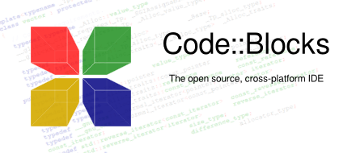**2.3 Software Tools Used**

**Code::Blocks:**

**Code::Blocks is a free, open-source cross-platform IDE that supports**

**multiple compilers including GCC, Clang and Visual C++. It is**

**developed in C++ using wxWidgets as the GUI toolkit. Using a plugin**

**architecture, its capabilities and features are defined by the provided**

**plugins. Currently, Code::Blocks is oriented towards C, C++, and**

**Fortran. It has a custom build system and optional Make support.**

**Code::Blocks is being developed for Windows and Linux and has been**

**ported to FreeBSD, OpenBSD and Solaris.**

**Chapter- 3: System Design**

**3.1 Flowchart**

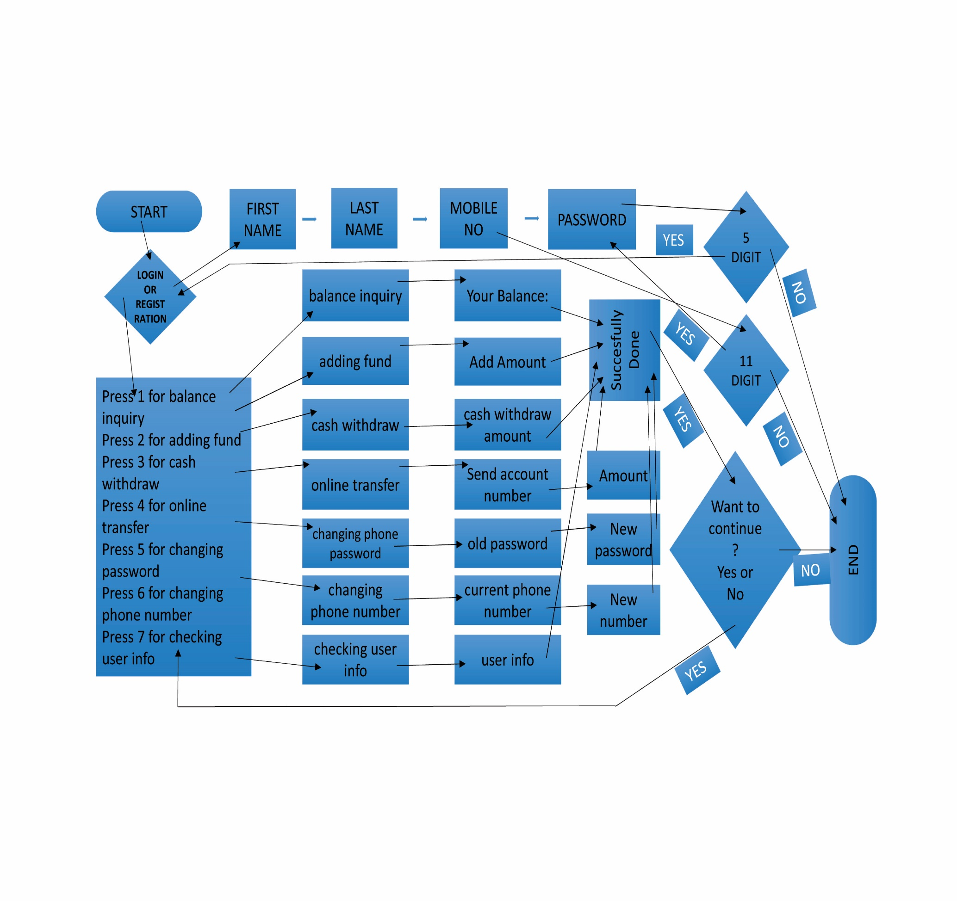

**Chapter- 4: System Implementation**

**4.1 Module Description**